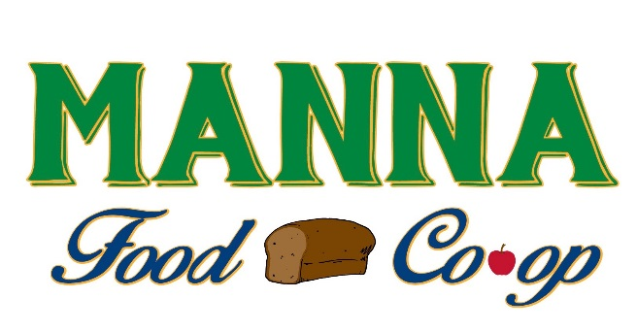
LOCAL JEWEL:
Leaving Our Community A Legacy Joining Everyone With
Excellent Living

The LOCAL JEWEL Sponsorship allows anyone the opportunity to donate MANNA Food Co-op Memberships or donate money to be put toward a membership to the Co-op, thus allowing all members of the community access to local healthy food no matter their means. The Co-op gives donated memberships to families and individuals who sign up using the below criteria. MANNA’s mission to bring health and access to local food is fulfilled in many different ways, and this is just another way we implement the mission locally.
Step 1: Membership Request or Donation (circle one)
- Request for LOCAL JEWEL Membership
- Donation of full membership ($150)
- Donation of $________ toward a membership

Step 2: One of the below criteria must be met to receive a donated membership. Donors may select any of these criteria if they want their donation to go to a specific cause: (Circle one or more and provide proof of the criteria)
- Current enrollment in the Supplemental Nutrition Assistance Program – EBT Card
- Current enrollment in the WIC (Women, Infants and Children) – Copy of Card
- Current enrollment in the Medicaid program – Copy of Card
- Current enrollment in the Free School Lunch Program – Copy of Paperwork
- Recent (within1 year) loss of an immediate family member, ie. child or spouse, Disability or Catastrophic Illness

Step 3: Contact Info
Sponsor Name: _____________________________________ Sponsor Phone: ____________________________
Sponsor E-mail (optional) ________________________________________________________________________
Recognition (circle): Yes or Anonymous

Recipient Name: _____________________________________ Recipient Phone: __________________________
Recipient Address: ______________________________________________________________________________
Recipient E-mail:________________________________________________________________________________

